3 LASTNAME Digital Image

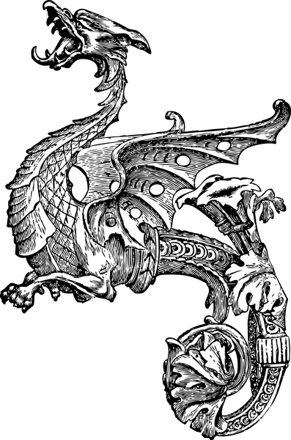
Dragon
Size: Large
Size adjusted to 2”

“Of all the monsters in myth and folklore, the dragon is the most familiar and the most feared. Winged dragons with flame and smoke pouring from their nostrils dominate the legends of many countries. The various species whose parts were combined into the dragon's hybrid form differed from one land to another.”

Works Cited

444868. Ink drawing of Dragon. Digital image. IClipArt. Grant Wood AEA, n.d. Web. 11 Sept. 2012
"Dragons." Compton's by Britannica. N.p.: n.p., n.d. Print.

