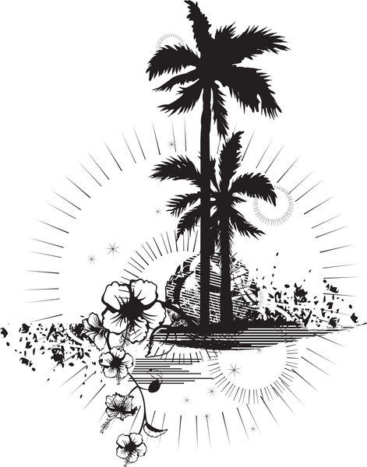
“Our memories of the ocean will linger on, long after our footprints in the sand are gone.”
--Anonymous
“Education … has produced a vast population able to read but unable to distinguish what is worth reading.”
- G. M. Trevelyan British historian

