Directions for creating a free STUDENT Prezi account.
Below is the difference between a student account that has been locked to private (the first one), and a public account which cannot be locked (the second one). This is important because I have not been able to convert the public accounts to the permanent FREE hidden/private STUDENT accounts – it has been a free one month trial student account. You cannot outsmart it and make the student a different account that is free . . .
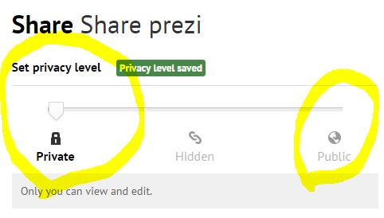
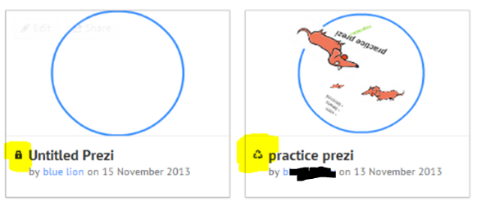

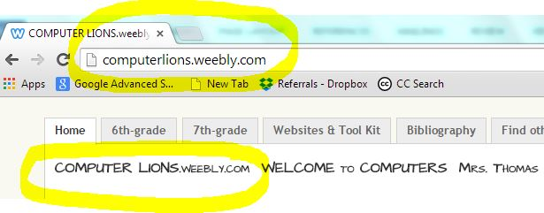

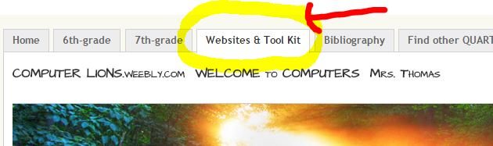

Websites & Tool Kit > Make and Create Something

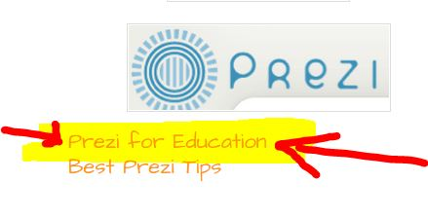

Directions for signing up for a FREE student account.

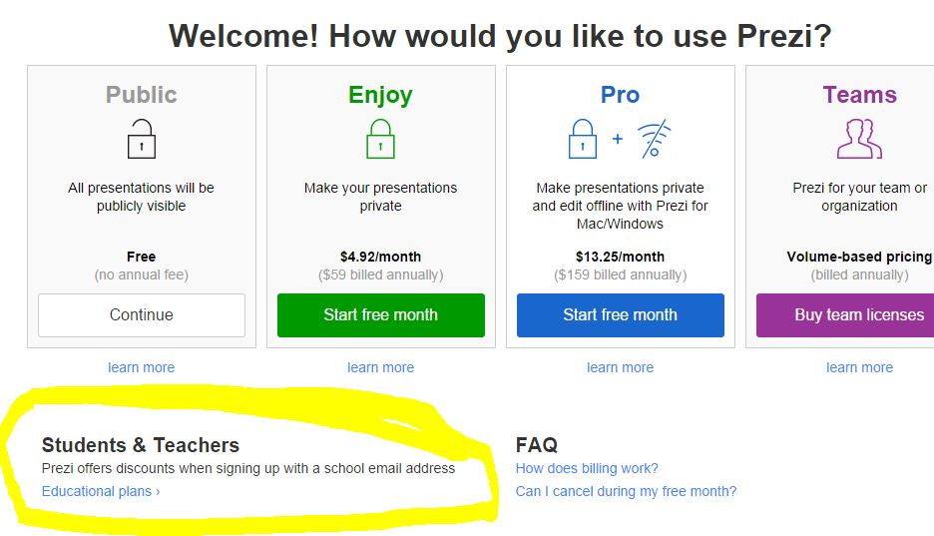

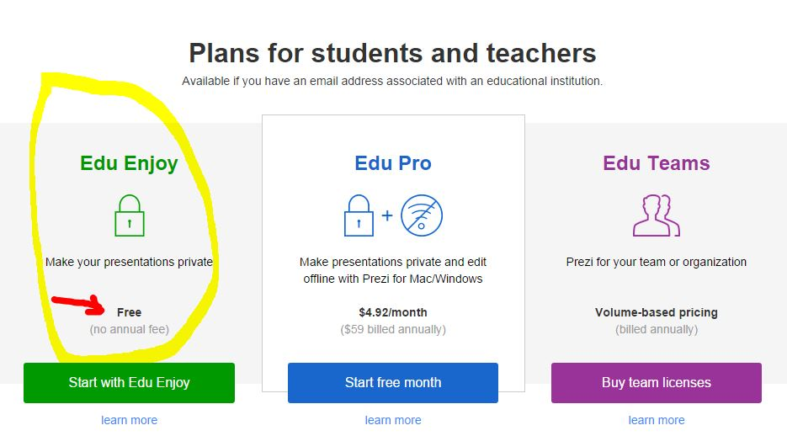

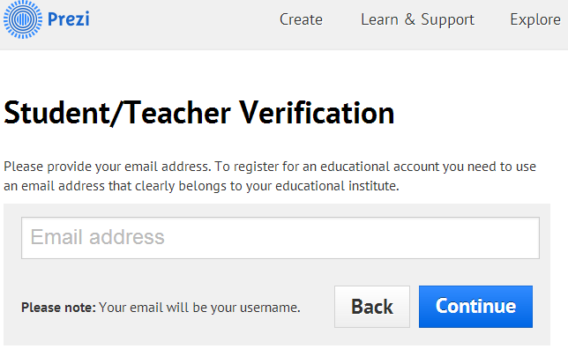

Students will be asked for their school, town, and school website:
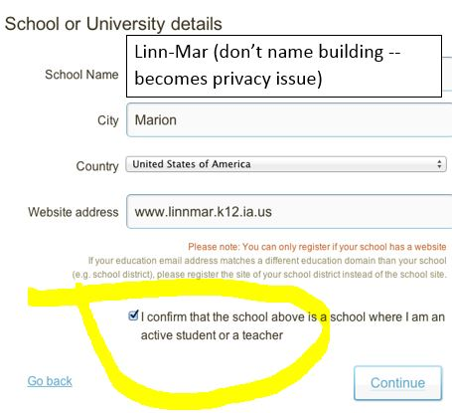

Students are using their school password as their Prezi password. They will need to have their school Outlook e-mail open to complete the registration process – clicking (copy & paste) the link that comes in their e-mail.

